Project Design Phase-II
Data Flow Diagram & User Stories

Date | 28-11-2025
Team ID
Project Name | Book a Doctor
Maximum Marks | 4 Marks

Data Flow Diagrams:
A Data Flow Diagram (DFD) explains how patients interact with the Book a Doctor system, how appointment data flows, and where it gets stored.
Example: DFD Level 0 (Industry Standard)

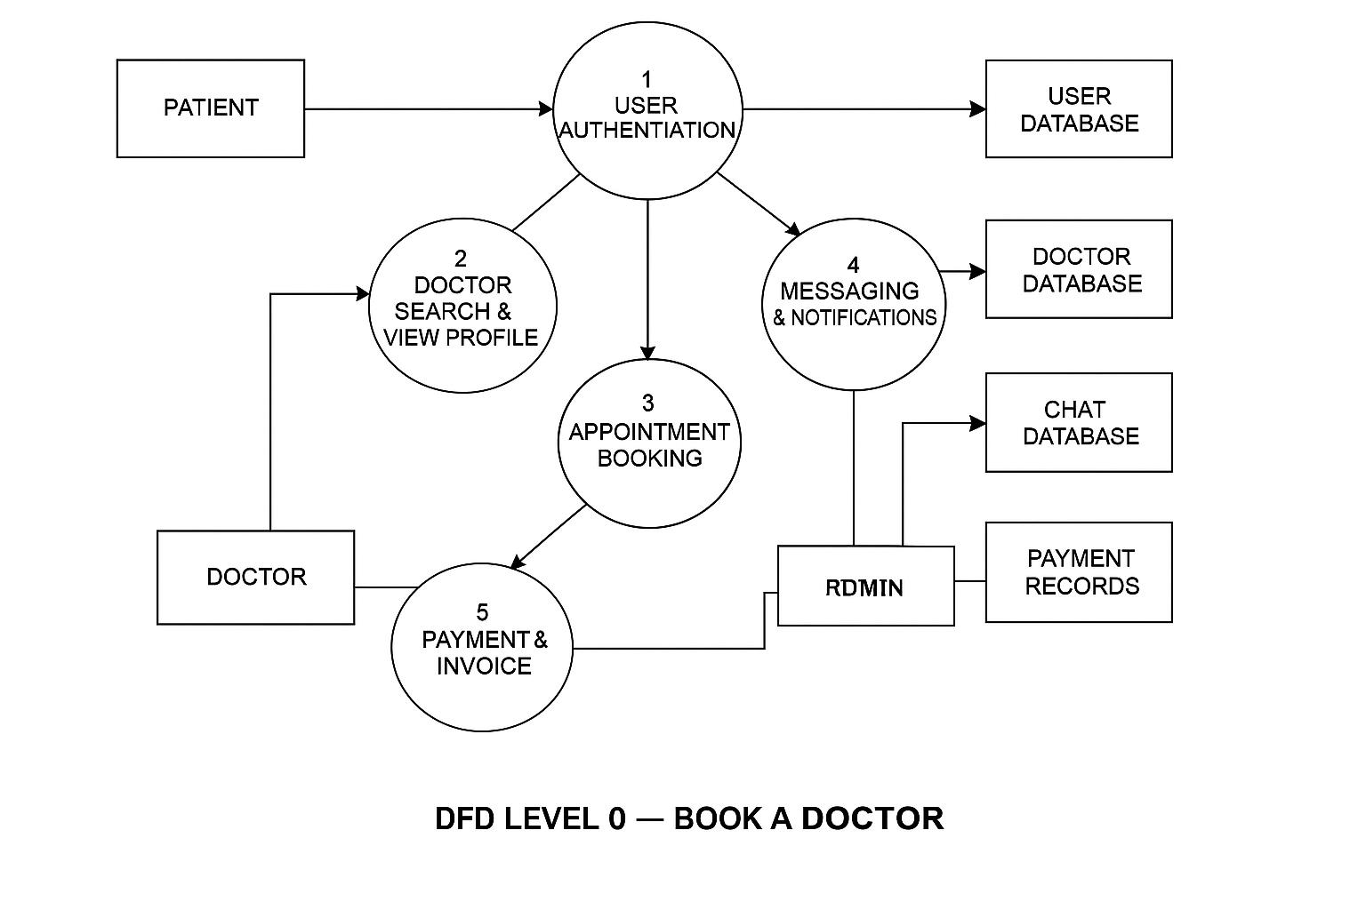

User Stories

User Story Table – Book a Doctor
User Type | Functional Requirement (Epic) | User Story / Task | Acceptance Criteria | Priority | Release
Patient |  | As a patient, I can search doctors based on specialization and location. | Relevant doctors are displayed. | High | Sprint-1
  Doctor Search
 |  | As a patient, I can book an appointment with a doctor by selecting a date & time. | Appointment is stored and confirmation is shown. | High | Sprint-1
  Patient
  Appointment Booking
 |  |  | Payment success message and receipt generated. | Medium | Sprint-2
  Patient
  Payment
  As a patient, I can make an online payment for my appointment.
Patient | Notifications | As a patient, I gat remainders before my appointment. | Notification received via email/SMS. | Medium | Sprint-3
Doctor | Profile Management | As a doctor, I can update my specialization, experience, and timings. | Updated details are visible to patients. | High | Sprint-1
Doctor | Appointment Management | As a doctor, I can view and manage booked appointments. | Appointment list loads correctly. | High | Sprint-2
user |  | As a user, I can give reviews after consultation. | Review appears on doctor's profile. | Medium | Sprint-3
  Review
Admin | Doctor Verification | As an admin, I can approve or reject doctor registration. | Verified doctors appear in search. | High | Sprint-1

